

**User Requirement Specification**

**Automatic Direct Debit for Corporate Customers**

|  |  |
| --- | --- |
| Date: | 28th April, 2020 |
| Issue number: | 1.0 |
| Document author: | Gloria Egbele |
| Project Owner: | Olubodun Akinkugbe |
| Project Sponsor: | Lynda Saint-Nwafor |

|  |
| --- |
| CONFIDENTIALITY |
| No part of this document may be disclosed verbally or in writing, including by reproduction, to any third party without the prior written consent of MTN Nigeria Communications Ltd. This document, its associated appendices and any attachments remain the property of MTN Nigeria Communications Ltd and shall be returned upon request. |

# Sign Off Sheet

The following signatories authorise this specification for implementation.

|  |  |  |  |
| --- | --- | --- | --- |
| Name | Representing | Signature | Date |
| Omowunmi Olatunbosun | SM, Solutions Development |  |  |
| Olubodun Akinkugbe | SM, Customer Support |  |  |
| Sonny Onyegbula | SM, Customer Operations |  |  |
| Onyinye Ikenna-Emeka | GM, Enterprise Marketing |  |  |
| Lynda Saint-Nwafor | CEBO |  |  |
| Ugonwa Nwonye | CCRO |  |  |
| Bukola Ajayi | GM IT Design & Delivery |  |  |
| Odunayo Sanya | GM Planning & Customer Management |  |  |
| Kolawole Oyeyemi | GM, Customer Experience |  |  |
| Nixon Wampamba | GM, Revenue Assurance |  |  |
| Ikenna Ikeme | GM, Regulatory Affairs |  |  |

Note

My signing this document indicates that I am in full agreement with its content and approve of it.

Note

My signing this document indicates that I am in full agreement with its content and approve of it.

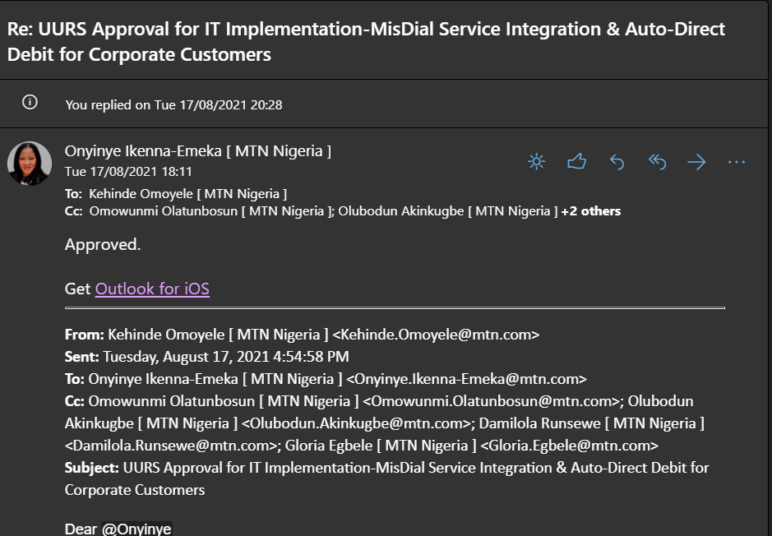

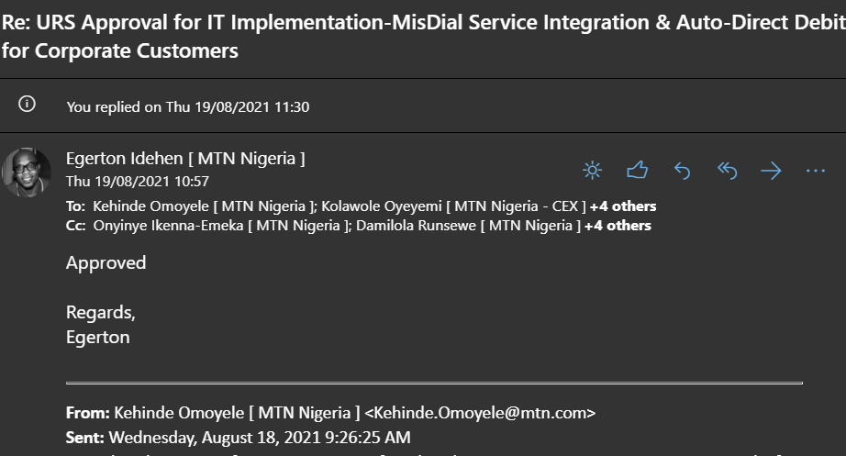

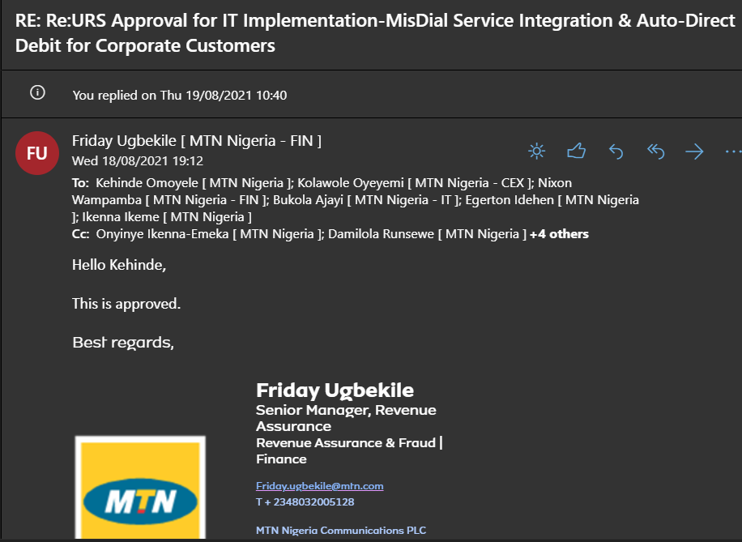

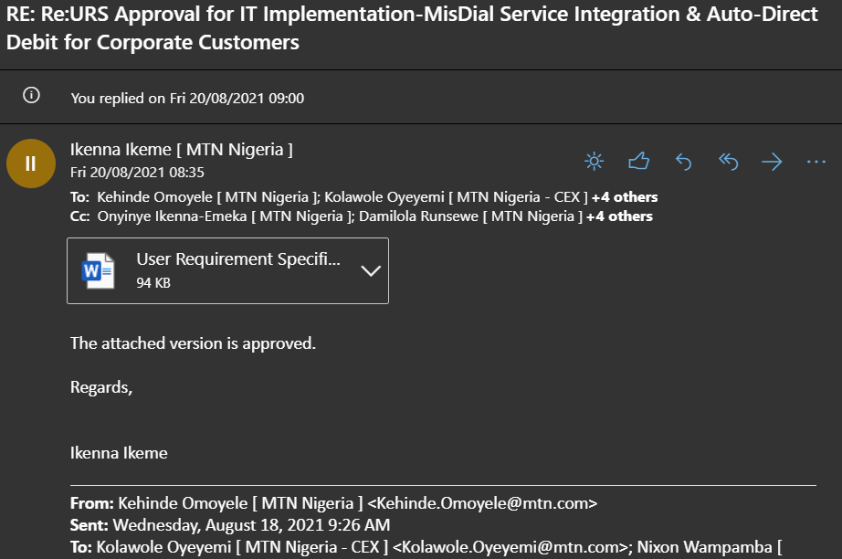

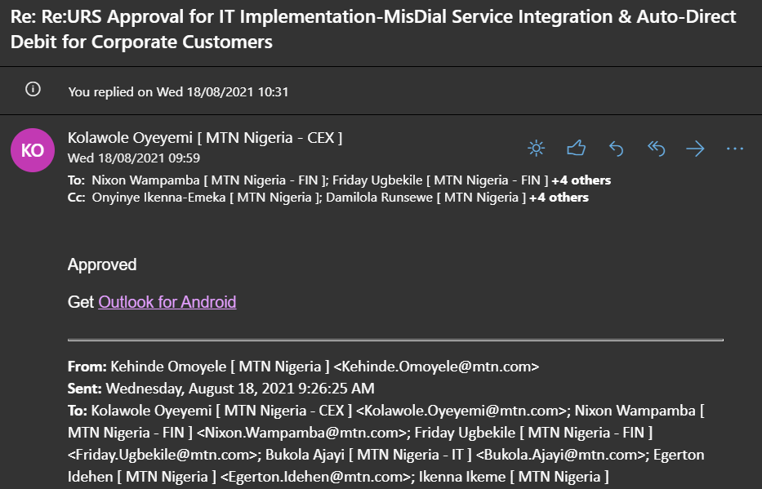

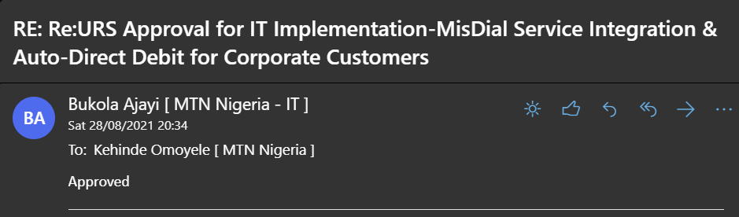

# Revision History

Please specify the details of the document changes.

|  |  |  |
| --- | --- | --- |
| **Version** | **Date** | **Reason for Change** |
| 1.0 | 27/04/2021 | First copy |
|  |  |  |

# Distribution List

Below listed is the relevant department that will be impacted and will need to be informed.

|  |  |
| --- | --- |
| Name | Representing |
| Victor Borisade | EB Credit & Banking |
| Gloria Egbele | EB Order Mgt & Billing (Credit & Banking) |
| Funke Olutola | EB Quality Mgt |
| Adedapo Shonoiki | EB Escalations |
| Osaretin Ogieriaikhi | EB Customer Support |
| Obinna-Pomerania Anucha | EB Customer Support |
| Lilian Ilechukwu | EB Customer Support |
| Mfon Peter-Udoh | CUS, Billing & Collections |
| Sonny Onyegbula | CR, Customer Operations |
| Ayoade Adedeji | Finance, Treasury Operations |
| Chidiebere Ugbaja | EB, Sales Development |
| Chukwuebuka Ezewuzie | IT, IN & VAS |
| Otasowie Ena-Umweni | IT, Solutions Delivery |
| Omowunmi Olatunbosun | EB, Solutions Development |

**Table of Contents**

Sign Off Sheet 2

Revision History 3

Distribution List 3

Type of Requirement 5

User Requirement Scope 6

Background 6

Requirements 7

Target segment 13

Benefits 14

Business Rules 14

New Business Rules 15

Business Processes 15

Existing Business Process 15

New Business Process 16

Reporting Requirements 19

Notification Requirements 24

Emergency or Fast Track Request 24

Motivation for Emergency/Fast Track 25

Appendix A 26

Glossary 26

# Type of Requirement

Please select one option from the list below to categorize this request.

New Product or Service

Change/Enhancement to Existing Product or Service

Bug Fix

New System / Application

Other (please describe in the box below)

|  |
| --- |
| Automatic Direct Debit |

Please select one option from the list below to categorize the business value and strategic objective of the request.

Best Customer Experience

Returns and Efficiency

Ignite commercial Performance

Growth through Data & Digital

Hearts and Mind

Technology Excellence

Please select one option from the list below to categorize the MTN strategic pillars the request is addressing.

Creating and managing stakeholder value,

Driving sustainable growth

Transforming our Operating model

Creating a Distinct customer experience

Innovation and Best Practice

Please indicate the number of users (Customers, Agents, Staff, etc.) projected to have access to the solution

|  |  |
| --- | --- |
| **Department** | **Count** |
| All EB Customer Enablement Partners & Mgt. team | Approximately 120 service accounts |

# User Requirement Scope

Background

In this section, provide the rational for the request. Also mention the objective of providing this solution.

|  |
| --- |
| Automatic Direct debit is a process where the subscriber would agree for automatic payment of invoices generated for every billing cycle. The Direct Debit Process document describes the activities involved from customers giving mandate, implementing the customer mandate on the billing system to when the payment deduction happens and gets recognized by the business.  It also defines activities around mandate renewal, termination, and Reporting Management. This is to ensure seamless direct payment debit process, enshrine a culture of proper prompt payment and prevent business risk that could arise from payment default for services deployed. |

Requirements

In this section, please describe your requirements in form of short, simple description of a feature required to provide the new capability achieving a specific goal

**Requirement Prioritization**

|  |  |
| --- | --- |
| Priority | Description |
| P1 | Functionality/Capability is a must Have for go live and non-negotiable for system deployment |
| P2 | Functionality/Capability is a must have for go live however a work around is acceptable as a stop gap |
| P3 | Functionality/Capability is a required however negotiable to be delivered in future phases |
| P4 | Functionality/Capability is a nice to have |

|  |  |  |
| --- | --- | --- |
| **#** | **Requirements** | **Priority** |
| **General Requirements** | | |
|  | The direct payment debit functionality shall be available for all Enterprise / Consumer products and services | P1 |
|  | It shall be possible for customers to give a standing instruction to the bank /online / Walk-in auto debit requisition to settle monthly bills. | P1 |
|  | It shall be possible for the bank to send the upload file to be updated to the customer accounts based on its billed amount | P1 |
|  | The direct debit customers would provide the Bank Account detail / debit or credit card information to the bank which will be linked with the operator’s bank account.  ***Note****: Bank shall determine the level of information require from customer to perform direct debit.* | P1 |
|  | The direct debit system shall be automatically triggered by the bank based on the billing cycle and payment due date of the customer | P2 |
|  | It shall be possible to keep better track and history of the direct debits with analytics, reports and activity logs on the direct debit platform | P1 |
|  | It shall be possible for the payment information to be shared by the bank as a bank file upload to the billing system | P1 |
|  | It shall be possible for the system to raise alert notifications where the direct debit fails and channel it through an escalation path where necessary | P1 |
|  | The direct debit system shall have the ability for the billing system to consider payment information and clear the pending invoice against the payment collected | P1 |
|  | The payment made shall be specific only to the full invoice due | P1 |
|  | The system shall allow the payment to impact the indicated invoice account only | P1 |
|  | Customer shall be made to get immediate value once payment is made | P1 |
|  | The direct debit system shall be flexible to allow for the removal, addition, and modification of direct debit functionality | P1 |
|  | The application shall also allow view of history of payments via direct debit per customer | P1 |
|  | The direct debit system shall automatically generate payment ID for each payment. This shall auto-reflect on the billing system and shall be captured in all transactions | P1 |
|  | The application shall have the capability to send pending notifications via email to the customer for both unsuccessful and failed direct debit initiated on the system. It shall also send this notification via email to the account support partner/CR Banking Support team | P1 |
|  | The application shall have the capability to send notifications via email to the customer for successful direct debit initiated on the system. It shall also send this notification via email to the account support partner | P1 |
|  | Email notifications shall be sent as reminder to customers 24hrs before direct debit action | P1 |
|  | System shall have the capability to track customers with failure status more than once | P1 |
|  | It shall be possible to perform refund where multiple credit transactions occur during the direct debit implementation. The Customer shall notify the Bank and MTN Customer Support Partner of multiple deduction and the internal refund process shall take care of the refund. | P2 |
|  | It shall be possible to have a refund button on CLM to process a refund to customer where there is over billing or double entry | P1 |
|  | The CLM shall trigger an approval to Treasury to process a refund to Customer Account | P1 |
|  | The Approved refund shall the sent to Bank to debit MTN account and credit Customer account for refund immediately | P1 |
|  | Where a refund process is approved by Treasury and Customer account is credited, such refund shall impact the customer next invoice with the value and detail narration  (i.e., a refund amount of Nxxx has been processed, date 20th May 2021).  ***Note****: Treasury approval date shall be captured as transaction date on the narration* | P1 |
|  | The refund narration shall be captured on CLM for customer management purposes. | P1 |
|  | Customer shall receive notification of insufficient fund when it occurs. | P1 |
|  | Where there is insufficient fund in Customer’s account, the system shall have the functionality to re-try automatically till end of the current month (>=25 days but < 28days). | P1 |
|  | It shall be possible for the system to trigger e-mail to Customer Support Partner of payment issue such as insufficient after the re-trial period. | PI |
|  | The direct debit application shall be able to send notifications detailing amount and invoice amount settled to the customer | P2 |
|  | It shall be possible to do invoice specific with direct debit functionality | P2 |
|  | It shall be possible to spool a report of all activities (end to end) on the direct debit application. This shall be exportable to MS Excel | P1 |
|  | It shall be possible to set up automated survey deployment for customers’ feedback via email and SMS | P1 |
|  | It shall also be possible to generate an automatic report based on the report specifications provided and required | P2 |
|  | Audit trails of all activities shall be available on the direct debit application at all times indicating name, date, time stamps of action and all activities performed | P1 |
|  | It shall be possible to determine payment made through direct debit application on the billing system | P1 |
|  | It shall be possible for Customer to opt out of Direct debit either by notifying the bank or MTN. | P1 |
|  | Where customer is opting out from direct debit, it shall be effective from the next billing cycle date. | P1 |
|  | It shall be possible for customer to agreed to part payment where there is insufficient fund. This shall generate a notification to customer with the Narration “Amount of Nxxe been part payment for invoice Noxxxxx” | P1 |
|  | Where customer agreed to Part payment, it shall be possible for the system to retry to clear the outstanding balance when the account is funded. Where the outstanding balance had been settled, the system shall generate a notification to customer with the Narration “Amount of Nxxe been outstanding payment for invoice No xxxxx” | P1 |
|  | Where customer made full payment through another channel, the system shall recognize and treat the invoice as fully settled, the direct debit shall not operate. | P1 |
|  | Where customer made part payment through another channel, the system shall treat the invoice as partly settled. Howver, the direct debit shall settle the balance, with the Narration “Amount of Nxxe been outstanding payment for invoice No xxxxx” | P1 |
|  | It shall be possible to request direct debit through selfcare, support partners and all MTN touchpoints | P2 |
|  | The direct debit amount shall reflect on the account immediately and the same amount can be seen on the billing system | P1 |
|  | It shall be possible for system to automatically do direct debit for subscription based products and services | P2 |
|  | It shall be possible for system to automatically do direct debit for usage-based invoices where monthly invoices are not the same month on month | P1 |
|  | It shall be possible for the system to store direct debit forms filled by customers | P1 |
|  | The functionality for Direct debit shall be possible / made available on all postpaid payment channels. | P1 |
|  | Direct Debit channel used by customer shall be indicated on the account or service on CLM | P2 |
|  | It shall be possible for customer to make use of tokenized cards in all Direct Debit application channels | P1 |
|  | All applicable security and authentication on tokenized cards available to customer shall be allowed in all the Direct Debit application journeys. | P1 |
| **MyMTN app/web** | | |
|  | Customer shall be able to apply for Direct Debit function via MyMTN app/web | P1 |
|  | Direct Debit request menu shall be added to the app interface | P1 |
|  | Customer shall be able to agree to T&C in order to proceed with the application | P1 |
|  | All applicable banks shall be available for selection on the app | P1 |
|  | Customer shall be able to input bank account ID or card details | P1 |
|  | Customer shall be able to input the following MTN account details as part of request set-up based on his or her preference  Account ID  Service ID | P1 |
|  | It shall be possible to captured customer email address and Contact Phone number as part of application process | P1 |
|  | E-mail address and Contact Phone shall be made mandatory | P1 |
|  | Customer shall be able to authenticate request with the use of bank Token or any other bank security validation processes | P1 |
|  | Once confirmed by customer Direct Debit shall become active on the account or service | P1 |
|  | Direct Debit application request shall be transmitted to the respective banks to commence debit actions at the appropriate times | P1 |
|  | Customer shall be able to cancel or opt out of Direct Debit function running on their account | P1 |
| **Zigi – MTN Chatbot** | | |
|  | Customer shall be able to apply for Direct Debit function via Zigi | P1 |
|  | Zigi shall be able to provide required answers and assist customer to complete Direct Debit application | P1 |
|  | Direct Debit request menu shall be added to the process | P1 |
|  | Customer shall be able to agree to T&C in order to proceed with the application | P1 |
|  | All applicable banks shall be available for selection on Zigi | P1 |
|  | Customer shall be able to input bank account ID or card details | P1 |
|  | Customer shall be able to input the following MTN account details as part of request set-up based on his or her preference  Account ID  Service ID | P1 |
|  | It shall be possible to captured customer email address and Contact Phone number as part of application process | P1 |
|  | E-mail address and Contact Phone number shall be made mandatory | P1 |
|  | Customer shall be able to authenticate request with the use of bank Token or any other bank security validation processes | P1 |
|  | Once confirmed by customer Direct Debit shall become active on the account or service | P1 |
|  | Direct Debit application request shall be transmitted to the respective banks to commence debit actions at the appropriate times | P1 |
|  | Customer shall be able to cancel or opt out of Direct Debit function running on their account | P1 |
| **MTN Shop/EB Agents – Customer Management System** | | |
|  | It shall be possible to action customer Direct Debit application from CLM | P1 |
|  | All applicable banks shall be available for selection on CLM | P1 |
|  | It shall be possible to input customer bank account ID | P1 |
|  | It shall be possible to set the Direct Debit application at account or service level | P1 |
|  | It shall be possible to captured customer email address and Contact Phone number as part of application process | P1 |
|  | E-mail address and Contact Phone number shall be made mandatory | P1 |
|  | Once the application is submitted by the Agent, Customer shall receive authentication request on the registered number with the bank and be able to authenticate request with the use of bank Token or any other bank security validation processes | P1 |
|  | Customer shall be able to agree to T&C in order to proceed with the application | P1 |
|  | Once confirmed by customer Direct Debit shall become active on the account or service | P1 |
|  | Direct Debit application request shall be transmitted to the respective banks to commence debit actions at the appropriate times | P1 |
|  | Agent shall be able to cancel Direct Debit running on customer account via CLM | P1 |
| **Debit Notification and timeline based on Customer Sub-Segment** | | |
| UR 87 | SME SOHO/MICRO and Consumer customers will receive debit notification on 3rd of every month – immediately after bill run | P1 |
| UR 88 | SME SOHO/MICRO and Consumer customers bank account will be debited on 5th of every month | P1 |
| UR 89 | Where there is a delay in bill run, customer’s grace period will be extended / reviewed by the same number of days for SME SOHO/MICRO and Consumer customers. | P1 |
| UR 90 | Large Enterprise, SME-Medium and SME Small customers that opted for direct debit will received debit notification on 8th of every month | P1 |
| UR 91 | Large Enterprise, SME-Medium and SME Small customers that opted for direct debit bank account will be debited on 10th of every month | P1 |
| UR 92 | Where there is a delay in bill run, customer’s grace period will be extended / reviewed by the same number of days for Large Enterprise, SME-Medium and SME Small customers | P1 |

Note: All P1 & P2 requirements forms customer acceptance criteria

# Target segment

Identify the various user classes/segments that you anticipate will use/adopt this product or service.

Internal Staff

Call Centre

Other *– <please specify the details>*

Dealers/Agents

Subscribers

*GSM Subscriber– Prepaid*

*GSM Subscriber–Postpaid*

*Visafone Subscriber- Prepaid*

*Visafone Subscriber- Postpaid*

*Data Subscriber –Prepaid*

*Data Subscriber –Postpaid*

*Fixed Line Subscriber –Postpaid*

*Fixed Line Subscriber –Prepaid*

*Mobile Financial Service Subscriber*

*Digital Services Subscriber*

*Other Subscriber – <ICT Subscribers>*

Enterprise

*SMEs*

*Corporate*

*Carriers*

Other – <please specify the details>

# Benefits

In this section, please detail the key benefits of the proposed Product/System

|  |
| --- |
| 1. Robust payment automation process to spreads the cost over a period that you agree with the organisation 2. Direct Debit payments come with a guarantee. So you're automatically protected by three important safeguards  * An immediate money back guarantee from your bank * Advance notice if the date or amount change * The right to cancel at anytime  1. It addresses the concerns around late payment 2. Direct debit system improves cashflow 3. It streamlines business banking and payment collection process |

# Business Rules

In this section describe the Business and Operational Rules that will drive or be impacted by this change. E.G. Service fulfilment/customer order management, service assurance/customer management, billing and revenue assurance, etc.

## New Business Rules

*<Describe the new business rules that will apply due to this change in the systems and software. These are policies/guidelines that govern the business processes executions and their actors >*

|  |  |
| --- | --- |
| **#** | **New Business Rule** |
| BR 1 | Direct Debit shall be made to impact the due invoice only |
| BR 2 | The payment channel shall be applicable to all invoiced postpaid products |
| BR 3 | Debiting of customer account shall happen only after the bill run |
| BR 4 | Only the Total for the billed bill cycle on the specific invoice shall be debited into customer account |
| BR 5 | The payment shall be made to be specific to the current billed invoice only |
| BR 6 | Once payment is transmitted into CLM/CBS, all the existing payment treatment processes shall apply |
| BR 7 | All refund must be approved by Treasury team before customer account is credited and MTN account debited |

# Business Processes

## Existing Business Process

*<Highlight the stepwise process and/or flowchart of the existing business processes that has been executed based on existing business rules. This should have the sequence of steps clearly highlighted. A Process must at a minimum contain a trigger, a set of activities and a defined output >*

| **Step** | **Task** | **Responsibility** |
| --- | --- | --- |
| 01 | **Start** |  |
| 02 |  |  |
| 03 |  |  |
| 04 | **End.** |  |

## New Business Process

*<Highlight the stepwise process and/or flowchart of the new business processes that should be executed based on new business rules. This should have the sequence of steps clearly highlighted. A Process must at a minimum contain a trigger, a set of activities and a defined output >*

| **Step** | **Task** | **Responsibility** |
| --- | --- | --- |
| 01 | **Start** |  |
| 02 | **Walk in to a bank branch** | **Customer** |
| 03 | **Apply for Direct Debit payment option**  **Agree to T&C**  **Indicate the preferred payment option and provide required details**  **Bank Account**  **Debit Card**  **Tokenised Card** | **Customer** |
| 04 | **Treats the request and activate Direct Debit option for customer across various systems automatically – MTN/Bank** | **Bank Staff – for Physical form** |
| 05 | **Invoice is generated at the end of the month** | **DCBS** |
| 06 | **Send invoiced amount to customer with notification of intended debit** |  |
| 07 | **Send customer invoiced amount to bank** | **DCBS** |
| 08 | **Process the invoiced amount and debit customer account to the tune of the invoiced amount** | **CPG** |
| 09 | **Transmit the debited value to MTN Systems**  **Send account debit notification to customer** | **CPG** |
| 10 | **Post the debited value into customer account to impact the specific invoice automatically** | **DCBS** |
| 11 | **Send Payment notification to customer** | **DCBS** |
|  | **End.** |  |

**MyMTN app/web/Online Banking**

| **Step** | **Task** | **Responsibility** |
| --- | --- | --- |
| 01 | **Start** |  |
| 02 | **Visit MTN Postpaid Payment channels –, App, Web Portals, Online Banking etc** | **Customer** |
| 03 | **Apply for Direct Debit payment option**  **Agree to T&C**  **Selects preferred payment option and provide required details**  **Bank Account**  **Debit Card**  **Tokenised Card** | **Customer** |
| 04 | **Process request and send authentication prompt to customer** | **System - app/web/Online Banking** |
| 05 | **Provide the required authentication details** | **Customer** |
| 06 | **Treats the request and activate Direct Debit option for customer across various systems automatically – MTN/Bank** | **System - app/web/Online Banking** |
| 07 | **Invoice is generated at the end of the month** | **DCBS** |
| 08 | **Send invoiced amount to customer with notification of intended debit** | **DCBS** |
| 09 | **Send customer invoiced amount to bank** | **DCBS** |
| 10 | **Process the invoiced amount and debit customer account to the tune of the invoiced amount** | **CPG** |
| 11 | **Transmit the debited value to MTN Systems**  **Send account debit notification to customer** | **CPG** |
| 12 | **Post the debited value into customer account to impact the specific invoice automatically** | **DCBS** |
| 13 | **Send Payment notification to customer** | **DCBS** |
|  | **End.** |  |

**Zigi**

| **Step** | **Task** | **Responsibility** |
| --- | --- | --- |
| 01 | **Start** |  |
| 02 | **Access MTN Zigi using the existing process and selects “Apply for Direct Debit”** | **Customer** |
| O3 | **Ask customer to agree to T&C in order to be able to proceed** | **Zigi** |
| 04 | **Agree to T&C**  **Selects preferred payment option and provide required details**  **Bank Account**  **Debit Card**  **Tokenised Card** | **Customer** |
| 05 | **Ask customer to input required Service or Account ID** | **Zigi** |
| 06 | **Customer inputs Service ID or Account ID** | **Customer** |
| 07 | **Ask for Bank details** | **Zig** |
| 08 | **Provide Account Number and other required details**  **Provide token from Tokenised Card** | **Customer** |
| 09 | **Process request and send authentication prompt to customer** | **Zigi** |
| 10 | **Provide the required authentication details** | **Customer** |
| 11 | **Treats the request and activate Direct Debit option for customer across various systems automatically – MTN/Bank** | **Systems/Zigi** |
| 12 | **Invoice is generated at the end of the month** | **DCBS** |
| 13 | **Send invoiced amount to customer and provide intended debit notification** | **DCBS** |
| 14 | **Send customer invoiced amount to bank** | **DCBS** |
| 15 | **Process the invoiced amount and debit customer account to the tune of the invoiced amount** | **CPG** |
| 16 | **Transmit the debited value to MTN Systems**  **Send account debit notification to customer** | **CPG** |
| 17 | **Post the debited value into customer account to impact the specific invoice automatically** | **DCBS** |
| 18 | **Send Payment notification to customer** | **DCBS** |
|  | **End.** |  |

**MTN Shops/Agent**

| **Step** | **Task** | **Responsibility** |
| --- | --- | --- |
| 01 | **Start** |  |
| 02 | **Visit MTN Shops**  **Contact EB Agent**  **… And request for Direct Debit application** | **Customer** |
| 03 | **Apply for Direct Debit payment option for customer and input all required details**  **Input customer Service or Account ID** | **Shop/EB Agent** |
| 04 | **Process request and send T&C to customer in order to be able to proceed** | **CLM/Systems** |
| 05 | **Agree to T&C**  **Provide the preferred payment option and other required details**  **Bank Account**  **Debit Card**  **Tokenised Card** | **Customer** |
| 06 | **Process request and send authentication prompt to customer** | **CLM/Systems** |
| 07 | **Provide the required authentication details** | **Customer** |
| 08 | **Treats the request and activate Direct Debit option for customer across various systems automatically – MTN/Bank** | **CLM/Systems** |
| 09 | **Invoice is generated at the end of the month** | **DCBS** |
| 10 | **Send invoiced amount to customer with notification of intended debit** | **DCBS** |
| 11 | **Send customer invoiced amount to bank** | **DCBS** |
| 12 | **Process the invoiced amount and debit customer account to the tune of the invoiced amount** | **CPG** |
| 13 | **Transmit the debited value to MTN Systems**  **Send account debit notification to customer** | **CPG** |
| 14 | **Post the debited value into customer account to impact the specific invoice automatically** | **DCBS** |
| 15 | **Send Payment notification to customer** | **DCBS** |
|  | **End.** |  |

# Reporting Requirements

<Specify reports required to manage and support the product, or solution. Example of such reports include revenue, sales, subscriptions, activity, activation, transaction based reports>

|  |  |  |  |  |  |  |  |
| --- | --- | --- | --- | --- | --- | --- | --- |
| **Request Type** | Report  - Complete sections 1, 2, 3, 5    Dashboard – Complete sections 1, 4, 5 | | | | | | |
| 1. **REPORT/USER DETAILS** (To be completed by Business User in the URS for each report required) | | | | | | | |
| **Report/Dashboard Name** | 1. **Enterprise/Consumer Direct Debit Report** 2. **Refund Report** 3. **3rd Party Report** | | | | | | |
| **Description** | Captures All Entries on the Enterprise direct debit application into separate columns for the different request, input and changes. Fields captured into separate columns | | | | | | |
| **Requester** | Gloria Egbele | | **Division/Department:** | | | Enterprise Business | |
| **Phone Number** |  | | **Date Requested** | | |  | |
| **Report Version** | New Report:    No Existing Report | | | | | | |
| **Report Frequency** | **Monthly**  **Weekly**  **Daily**  On Demand | | **Report Format** | | | **XLS**  **CSV**  PDF  **Database View/table**  **Dashboard** | |
| 1. **REPORT OUTPUT PARAMETERS** (To be completed by Business User for each report required) | | | | | | | |
| **S/N** | **Field Name** | | **Description** | | | | |
| 1 | Profile ID (From Order Management System) | | Unique ID assigned to a profile on the billing system | | | | |
| 2 | Account ID (From Order Management System) | | The account level ID of the account(s) created as a result of the account | | | | |
| 3 | Service ID | | MSISDN, DN, Username | | | | |
| 4 | Customer Name | | Name of external Customer | | | | |
| 5 | Segment(Corporate, Carrier, SME, Consumer) | | Section which document is administer | | | | |
| 6 | Type of Service | | Specify the type of service for uptake | | | | |
| 7 | Amount | | Details of direct debit amount | | | | |
| 8 | Bank Name | | Name of donor bank | | | | |
| 9 | Time stamp | |  | | | | |
| 10 | Status | |  | | | | |
| 11 | Refund Status | |  | | | | |
| 12 | Transaction Ref ID | | Transaction reference | | | | |
| 13 | Invoice Amount | |  | | | | |
| 14 | Comments | | Track comment | | | | |
| 15 | Administrator/authorize user name | | Pick name of user and commenters | | | | |
| 1. **SEARCH PARAMETERS** (To be completed by Business User for each report required) | | | | | | | |
| **S/N** | **Field Name** | | **Description** | | | | |
| 1 | Service Link Code | | Profile ID, Service ID, Account ID, Customer Name, Segment, Type of Service | | | | |
| 2 | Profile ID | | Unique ID assigned to a profile on the billing system | | | | |
| 3 | Account ID | | The account level ID of the account(s) created as a result of the account | | | | |
| 4 | Service ID | | MSISDN, DN, Username | | | | |
| 5 |  | |  | | | | |
| 6 |  | |  | | | | |
| **NB: These are samples so shouldn’t be limited to this**   1. **DASHBOARD PARAMETERS** (To be completed by Business User for each dashboard required) | | | | | | | |
| **Dashboard Details** | | | | | | | |
| **CHARTS** | | | | | | | |
| | X |Bar   |   | Pie  |   | Line   |   | Legend   |   | Others (Please specify): | | | | | | | |
| Chart Axis | | | | | | | |
| X Axis | | | | Y Axis | | | |
|  | | | |  | | | |
|  | | | |  | | | |
| Chart Description | | | | | | | |
| **NB: These are samples so shouldn’t be limited to this** | | | | | | | |
| 1. **DESIGN PARAMETERS** (To be completed by VAS Planning/Design Engineer) | | | | | | | |
| **PRODUCT CATALOGUE** *Please list all parameters defined in the solution* | | | | | | | |
| **PARAMETERS** | **PRODUCT 1** | **PRODDUCT 2** | **PRODUCT 1** | | **PRODDUCT 2** | | **PRODUCT n** |
| Product Name |  |  |  | |  | |  |
| Product ID |  |  |  | |  | |  |
| Service ID |  |  |  | |  | |  |
| Activation PAM ID |  |  |  | |  | |  |
| Deactivation PAM |  |  |  | |  | |  |
| Offer ID |  |  |  | |  | |  |
| Eligible SC |  |  |  | |  | |  |
| Rate |  |  |  | |  | |  |
| UT/UC |  |  |  | |  | |  |
|  |  |  |  | |  | |  |
|  |  |  |  | |  | |  |
|  |  |  |  |  |  |  |  |

|  |  |  |  |  |  |  |  |
| --- | --- | --- | --- | --- | --- | --- | --- |
| **Request Type** | Report  - Complete sections 1, 2, 3, 5    Dashboard – Complete sections 1, 4, 5 | | | | | | |
| 1. **EPORT/USER DETAILS** (To be completed by Business User in the URS for each report required) | | | | | | | |
| **Report/Dashboard Name** | **Enterprise/Consumer CR Direct Debit Report**  **Refund Report**  **3rd Party Report** | | | | | | |
| **Description** | Captures All Entries on the Enterprise/Consumer direct debit application into separate columns for the different request, input and changes. Fields captured into separate columns | | | | | | |
| **Requester** | Gloria Egbele | | **Division/Department:** | | | Enterprise Business | |
| **Phone Number** |  | | **Date Requested** | | |  | |
| **Report Version** | Modify Existing Report | | | | | | |
| **Report Frequency** | **Monthly**  **Weekly**  **Daily**   On Demand | | **Report Format** | | | **XLS**  **CSV**  PDF  **Database View/table**  **Dashboard** | |
| 1. **REPORT OUTPUT PARAMETERS** (To be completed by Business User for each report required) | | | | | | | |
| **S/N** | **Field Name** | | **Description** | | | | |
|  |  | |  | | | | |
|  |  | |  | | | | |
|  |  | |  | | | | |
|  |  | |  | | | | |
|  |  | |  | | | | |
|  |  | |  | | | | |
|  |  | |  | | | | |
|  |  | |  | | | | |
|  |  | |  | | | | |
|  |  | |  | | | | |
|  |  | |  | | | | |
|  |  | |  | | | | |
|  |  | |  | | | | |
|  |  | |  | | | | |
|  |  | |  | | | | |
|  |  | |  | | | | |
|  |  | |  | | | | |
| 1. **SEARCH PARAMETERS** (To be completed by Business User for each report required) | | | | | | | |
| **S/N** | **Field Name** | | **Description** | | | | |
| 1 |  | |  | | | | |
| 2 |  | |  | | | | |
| 3 |  | |  | | | | |
| 4 |  | |  | | | | |
| 5 |  | |  | | | | |
| 6 |  | |  | | | | |
| **NB: These are samples so shouldn’t be limited to this**   1. **DASHBOARD PARAMETERS** (To be completed by Business User for each dashboard required) | | | | | | | |
| **Dashboard Details** | | | | | | | |
| **CHARTS** | | | | | | | |
| | X |Bar   |   | Pie  |   | Line   |   | Legend   |   | Others (Please specify): | | | | | | | |
| Chart Axis | | | | | | | |
| X Axis | | | | Y Axis | | | |
|  | | | |  | | | |
|  | | | |  | | | |
| Chart Description | | | | | | | |
| **NB: These are samples so shouldn’t be limited to this** | | | | | | | |
| 1. **DESIGN PARAMETERS** (To be completed by VAS Planning/Design Engineer) | | | | | | | |
| **PRODUCT CATALOGUE** *Please list all parameters defined in the solution* | | | | | | | |
| **PARAMETERS** | **PRODUCT 1** | **PRODDUCT 2** | **PRODUCT 1** | | **PRODDUCT 2** | | **PRODUCT n** |
| Product Name |  |  |  | |  | |  |
| Product ID |  |  |  | |  | |  |
| Service ID |  |  |  | |  | |  |
| Activation PAM ID |  |  |  | |  | |  |
| Deactivation PAM |  |  |  | |  | |  |
| Offer ID |  |  |  | |  | |  |
| Eligible SC |  |  |  | |  | |  |
| Rate |  |  |  | |  | |  |
| UT/UC |  |  |  | |  | |  |
|  |  |  |  | |  | |  |
|  |  |  |  | |  | |  |

# Notification Requirements

*<Will there be notification messages to customer or error messages, please indicate>*

|  |  |  |
| --- | --- | --- |
| *Message Scenarios* | *Message content* | *Notification Medium e.g Flash message, sms, email, application pop up, scroller message etc* |
| When payment has successfully reflected on the system | Dear [Name], payment of Nxxxxx has been successfully received on your account | Application pop up, email |
| When payment fails  *[The customer that initiated the direct debit will be informed]* | Dear [Name], Direct payment failed due to insufficient fund, Please fund your account | SMS, email |

# 

# Emergency or Fast Track Request

In order to qualify as an emergency request the request must meet one or more of the following criteria (select all that apply)

Revenue leakage

Competitive advantage

Legal or regulatory requirement

Security issue in system

Vendor misinterpretation of previous requirement

Bug in the system

Revenue growth opportunity in the future

# Motivation for Emergency/Fast Track

*<Motivate the request for emergency status in this section.>*

|  |
| --- |
|  |

# Appendix A

## Glossary

|  |  |
| --- | --- |
| Abbreviation | Meaning |
| *CSP* | *Customer Support Partner* |
| *AP* | *Account Partner (Sales)* |
| *PPPs* | *Policy, Processes and Procedures* |
| *Mgr.* | *Manager* |
| *Snr* | *Senior* |
| *DD/MM/YYYY HH:MM* | *Day/ Month/Year Hour : Minute* |
| *URS* | *User Requirements Specifications* |
| *ID* | *Identity* |
| *EB* | *Enterprise Business Division* |
| *SLA* | *Service Level Agreement* |
| *MTTR* | *Mean Time to Resolve/Repair* |
| *SC* | *Service Class* |
| *NGN* | *Nigerian Naira* |
| *USD* | *United States Dollar* |
| *ICT* | *Information & Communication Technology* |
| *SME* | *Small and Medium Enterprises* |
| *Mgt.* | *Management* |